Data Mining Project

Team

Daniel Hanspeter 6129

Thomas Schievenin 5701

# Datasets:

**Blood transfusion**

**Census-Income**

# PROJECT STEP ONE

## What is the data about?

1. Blood transfusion

This data is as the name says a collection of data taken from blood transfusions and to be more precise, it was collected at the Blood Transfusion Service Center in Hsin-Chu City in Taiwan. The data is collected randomly from donors and is used to achieve a Frequency-Metric-Model of donations, focusing on March 2007.

1. Census-Income

This data is a census done by the US Census Bureau investigating about the income class of randomly taken people, taking in account their education, current living situation and so on.

## How many attributes describe the data? What are the types of these attributes?

1. Blood transfusion

The data collected focuses on the donor’s situation, namely on the amount of done donations before, of the total amount of donations and so on, for a total of 5 Attributes. The data collected is focused on March 2007, since one attribute collects exactly if one person donated in March 2007 or not. All collected data is numerical, except for the donation in March ’07 which is a bit / Boolean attribute.

1. Census-Income

The data is described by 14 attributes detailing each person’s situation (i.e. martial-status). The attributes type vary, since some are numerical values as the age, and others are explicit defined fields (nominal), such as the native country (i.e. United-States)

## Are there missing values? If, yes propose a method to deal with missing values.

1. Blood transfusion

No missing values in the Dataset.

1. Census-Income

Around 7% of Attributes are missing. To work with that data, we can easily set a default value, like for instance an average if the value is continuous or the most occurring in order to not affect statistics.

## If the data has numeric attributes, choose at least two attributes and define their distributions. Represent these distributions using Boxplots. Which kind of conclusions you derive from these representations? Are there any outliers?

1. Blood transfusion

|  |  |  |
| --- | --- | --- |
| Label | Frequency (times) | Monetary (c.c. blood) |
| Min | 1 | 250 |
| Q1 | 2 | 500 |
| Median | 4 | 1000 |
| Q3 | 7 | 1750 |
| Max | 50 | 12500 |
| IQR | 5 | 1250 |
| Upper Outliers | 45 | 45 |
| Lower Outliers | 0 | 0 |
| *For the Box (IQR and Median)* | |  |
| Q2-Q1 | 2 | 500 |
| Q3-Q2 | 3 | 750 |
| *For the Whiskers* | |  |
| Q3+1.5*IQR | 14,5 | 3625 |
| Q1-1.5*IQR | -5,5 | -1375 |
| Upper Whisker | 14,5 | 3625 |
| Lower Whisker | 1 | 250 |
| Wupper-Q3 | 7,5 | 1875 |
| Q1-Wlower | 1 | 250 |
| *For the Outliers* | |  |
| Max | 50 | 12500 |
| Min | #N/A | #N/A |

As derivable from the Boxplots in both collected values there are Positive outliers.

For the Monetary (c.c. blood) Boxplot we can say that the values are located in a very short range, by noticing that the whiskers are just below/above the box ranges

1. Census-Income

|  |  |  |  |  |  |  |  |  |  |  |  |  |  |
| --- | --- | --- | --- | --- | --- | --- | --- | --- | --- | --- | --- | --- | --- |
| Labels | Education-num | hours-per-week |  |  |  |  |  |  |  |  |  |  |  |
| Min | 1 | 1 |  | | | | | | | | | | |
| Q1 | 9 | 40 |
| Median | 10 | 40 |
| Q3 | 12 | 45 |
| Max | 16 | 99 |
| IQR | 3 | 5 |
| Upper Outliers | 0 | 3492 |
| Lower Outliers | 1198 | 5516 |
| *For the Box (IQR and Median)* | | |
| Q2-Q1 | 1 | 0 |
| Q3-Q2 | 2 | 5 |
| *For the Whiskers* | |  |
| Q3+1.5*IQR | 16,5 | 52,5 |
| Q1-1.5*IQR | 4,5 | 32,5 |
| Upper Whisker | 16 | 52,5 |
| Lower Whisker | 4,5 | 32,5 |
| Wupper-Q3 | 4 | 7,5 |
| Q1-Wlower | 4,5 | 7,5 |
| *For the Outliers* | |  |
| Max | #N/A | 99 |
| Min | 1 | 1 |
|  |  |  |

We can deduce from the Boxplots that there are Minima and Maxima located largely outside the 50% of the data. “Hours-per-week” gives us an example of a complete Boxplot, having also a Max and Min Outlier.

## Define how to measure the similarity between the data objects according to the attribute types of your datasets?

1. Blood transfusion

Since all values (except the binary value for doing transfusion in march 07) in this Dataset are numeric ones, to compare on similarity we can calculate the distance using the Minkowski distance, by first cleaning up the data by bringing attributes to a unit-less form.

1. Census-Income

Here we have in addition to numeric values also nominal values. In this case we can do a simple matching or we could create a binary mapping for those values

## Define the data mining tasks that can be performed on the chosen datasets:

1. Blood transfusion

For this Dataset we can only do a prediction on the amount of blood donated and the times a person donated and vice versa. So we can build a classifier. The other attributes, like the monthly distance towards the last donation, can’t be connected to the other attributes in a reasonable way.

1. Census-Income

This Dataset gives us more fields to play with. In fact, we can create classifiers, decision trees make predictions etc. upon all attributes, pointing to the income class for instance. For example we could construct a tree which tells us if a 20-24 or a 25-30 with different work class can be mapped in a >50K income class.

E.G Age + Work 🡺 Class income: >50K /<=50K

25-30

20-24

Yes

No

Yes

No

# PROJECT STEP TWO

# PROJECT STEP THREE

## Define the important parameters of each algorithm

|  |  |  |  |  |
| --- | --- | --- | --- | --- |
|  | Decision tree | Naïve Bayesian Classifier | Logistic Regression | KNN classifier |
| Input Parameter | The attributes of a tuple | The posterior probabilities of Hypothesis H based on additional information | The measure of the total contribution of all independent variables used in the model. | A new unknown tuple for which a class has to be assigned. |
| Principle | The attributes of a tuple are tested against the decision tree and a path is traced from the root to a leaf node which holds the  prediction for that tuple | Given a tuple X, the classifier will predict that X belongs to the  class having the highest posterior probability conditioned on X. | Given x representing the exposure to  some set of risk factors, LR predicts the probability of occurrence of an event by fitting  data to a logistic curve, f(x), which represents the probability of  a particular outcome | Nearest-neighbor classifiers compare a given test tuple with  training tuples that are similar and described by n attributes and are stored in n-dimensional space  🡺 Find the k-nearest tuples from the training set to the unknown tuple |
| ALG. FORMULA | At start, all the training tuples are at the root. Then, tuples are partitioned recursively based on selected attributes. The test attributes are selected on the basis of a heuristic or statistical measure (e.g., information gain). We stop when all samples for a given node belong to the same class or there are no remaining attributes for further partitioning 🡺 majority voting. | At start, compute P(C) The prior probability of $C_{i}$. Each class can be computed based on the training tuples. Then compute each independent probability for attribute xi in reference with Class C and multiply P (|C). Example: The probability of class C to be yes is P(C) = 9/14. The amount of attribute Xi being test with respect to C is P(|) =  Finally, compute P(X|)P($C_{i}$) for each class 🡺 The naïve Bayesian Classifier predicts C=yes for tuple X | Since x is defined as x = $β_{0}+β_{1}X_{1}+…+β_{k}X_{k}$ the LR is $$\frac{e^{β_{0}+β_{1}X_{1}+…+β_{k}X_{k}}}{1+e^{β_{0}+β_{1}X_{1}+…+β_{k}X_{k}}}$$ Estimate the parameters using the Maximum Likelihood Function and then by computing the partial derivatives of the log likelihood, equate each partial derivative to zero, and solve the resulting nonlinear equations | The ALG assigns for the unknown tuple the most common class among its k-nearest neighbor. When k=1 the unknown tuple is assigned the class of the training tuple that is closest to it. To measure the distance we can use the Euclidean distance $\sqrt{\sum_{i=1}^{n}{{\left(x_{1i}-x_{2i}\right)}^{2}}}$ **Choose K:** If k=1 the classification will be 1:1 sensitive to other data.  If k=n we’ll suffer high noise.  Go through various K’s and choose one giving lowest misclassification error! |

## Observe the behavior of the different algorithms: What is your first observation? What are the measures used in the evaluation of the classifiers?

1. Blood transfusion

INTRODUCE ATTRIBUTE CLASS: BIG DONATOR – SMALL DONATOR

### Decision Tree

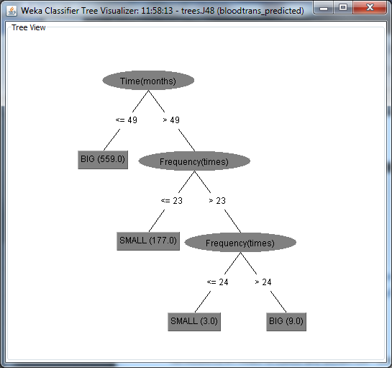On the training set On the test set

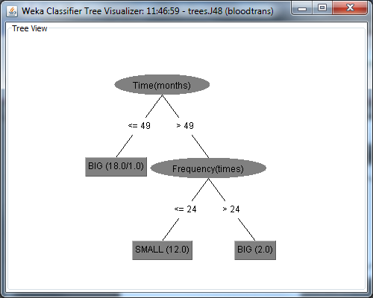

1. Census-Income

## Find methods that give you more information about the classification process (e.g., print the tree)

## What are the difficulties you have encountered to apply the algorithms on your datasets and how did you solve them?

# PROJECT STEP FOUR